How to reach the Dipartimento di Informatica in Pisa
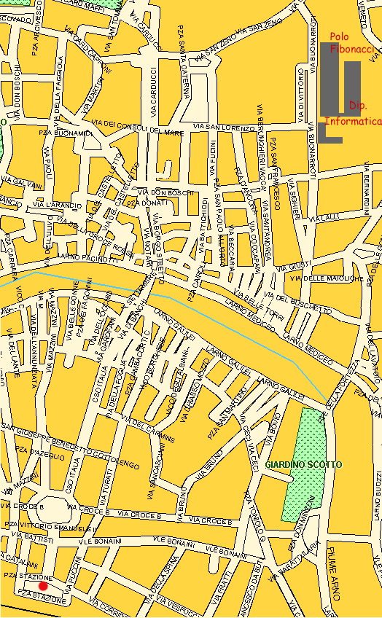

Pisa is traversed south to north by main street (Corso Italia, south to river Arno, and Borgo Stretto – Borgo Largo, north to the river) These streets are connected by Ponte Di Mezzo (Ponte means bridge). Once you are at the Ponte di Mezzo, go north in Borgo Stretto, go straight in Borgo Largo and, when Borgo Largo narrows, turn right in Via S. Lorenzo. The building at the end of via San Lorenzo is the Dept. of Mathematics. To the left of the Dept. of Mathematics, you can enter the Polo Fibonacci. The second building on the left is the one hosting the Dept. of Computer Science (Dipartimento di Informatica) at the second floor.

